Activity Diagram
This activity diagram illustrates the process of enrolling in a course within an online learning system. It shows the interaction between two main actors: the Student and the System. The swimlanes divide their responsibilities clearly, demonstrating how the process flows between user input and system responses.
The diagram begins with the student entering their username and password. If the student does not have an account, the system guides them to create one by entering their email, name, and a new password. The system then validates the input and checks whether the user already exists. Once the login or registration is successful, both paths merge, and the student proceeds to the course selection stage.
Next, the student enters the name of the course they wish to enroll in, while the system checks the availability of that course. If the course is found, the student continues to the payment step and enters payment details. The system then verifies the payment. When the payment is approved, the enrollment is confirmed, completing the process.
Throughout the diagram, decision nodes (diamonds) are used to represent logical choices, such as whether an account exists, whether input is valid, or whether payment is approved. Synchronization bars are used to merge different paths, ensuring a smooth flow from registration or login to final enrollment.
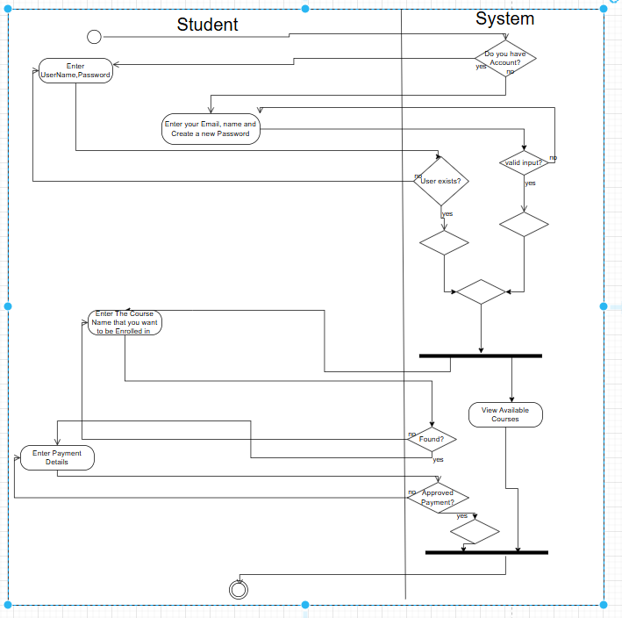
Use Cass Diagram
The Use Case Diagram shows how the main actors—Student, Instructor, and Admin—interact with the SkillForge Learning Platform. It outlines each actor’s goals and the system’s core functionalities. This diagram provides a clear overview of the system’s main features and user roles.
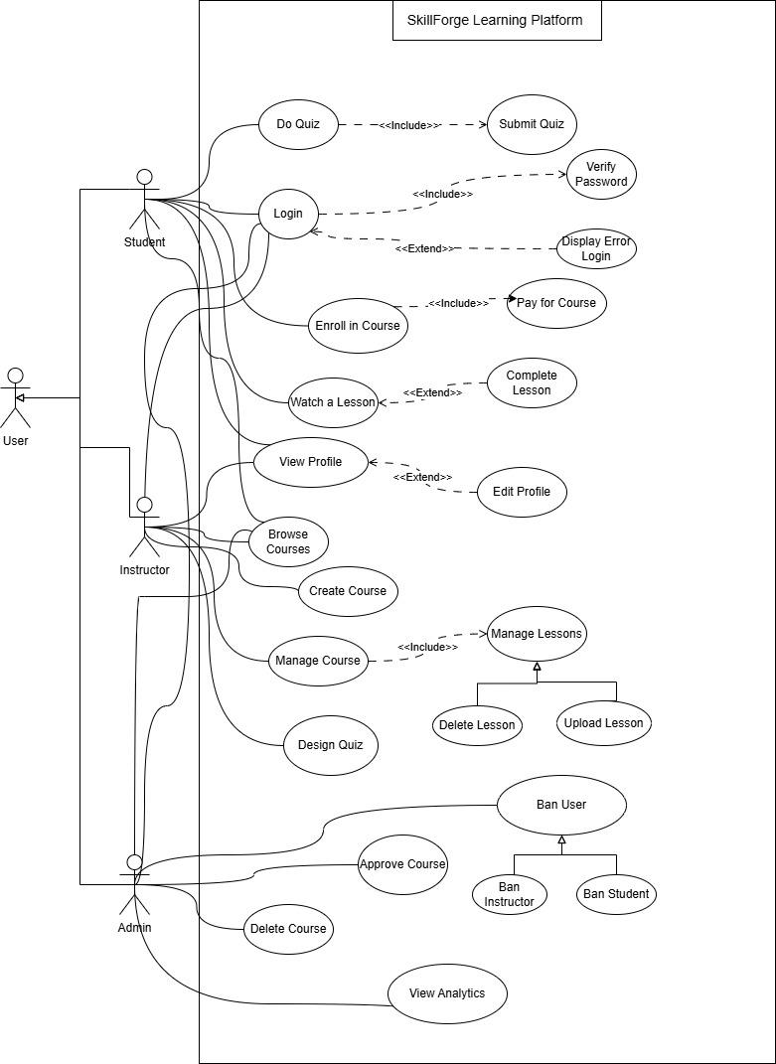
Sequence Diagram
This sequence diagram illustrates the interaction between the Student, User Interface, Course Service, and JsonDatabaseManager during the “Enroll in a Course” process. It shows how a student views available courses, selects one, and how the system processes the enrollment request by communicating with the database. This diagram is important because it visualizes the message flow and timing between system components, helping developers understand how different parts of SkillForge collaborate to complete the enrollment operation.
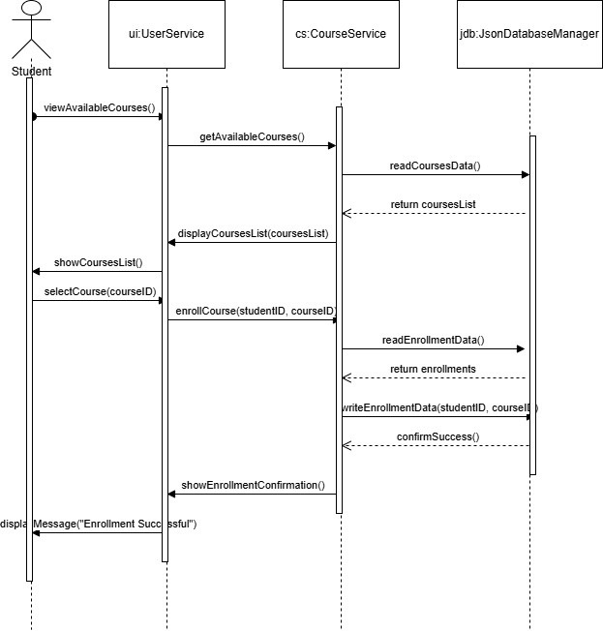

Class Diagram

